

|  |  |
| --- | --- |
| **Web technologies | Front-End** | |
| Student(s’) name(s): | Bikulova Nazerke, Amanzhan Aida, Askarbek Marat |
| Teacher name: | Dariya Bissengaliyeva |
| Project name: | Profile Website |
| Project type: | Group |

**INTRODUCTION**

Our team was inspired by people creating vignettes to commemorate their high school (and other) years. After a short thought about how we could implement this idea, we came to the common decision to create a “Profile Website”. Now there is no need to keep the vignette in a far corner of the closet, because now we can easily go to the site and look, maybe even remember all the classmates. In this project HTML, CSS, JavaScript, jQuery, Bootstrap was used.

**MAIN PART (Practical) | Information about developers and their responsibilities.**

This website provides an opportunity to see all CS-2124 group members and find out how old they are at the moment, what city they were born in, and their date of birth. Also, they can register themselves. There was created something along the lines of a calendar-helper analog for teachers and our classmates. In understanding the code, perhaps the most difficult thing was to deal with the scale and readability of the site. As most of the work was done on laptops, the default setting in Windows is 125% zoom, which made the site seem crooked. All errors were fixed. JavaScript made the website more visualized and interactive. Jquery and Bootstrap made our work easier and fast.

We changed the navbar, it is hiding now. Looks more interesting and modern. The ikon on the right top is representing the navbar. When you click on it links to other pages appear. Also, you can view some animations. “click”, “mouseover”, “keypress” functions were used in the animation part. It changes color when you navigate to the exact place with the mouse.

We added a questionnaire on the Info page. You can select between two options now. An animated button was used also. The function” hover” was used in this part.

Made a 3D version of the table. Made pictures more rounded and added shadows. Changed social media links, now links were connected to the icons, not to the words.

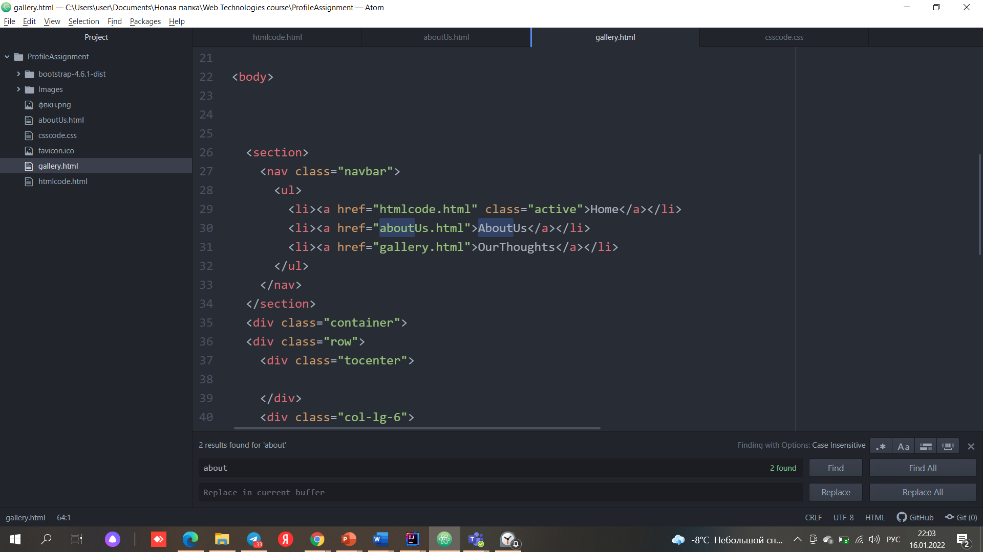

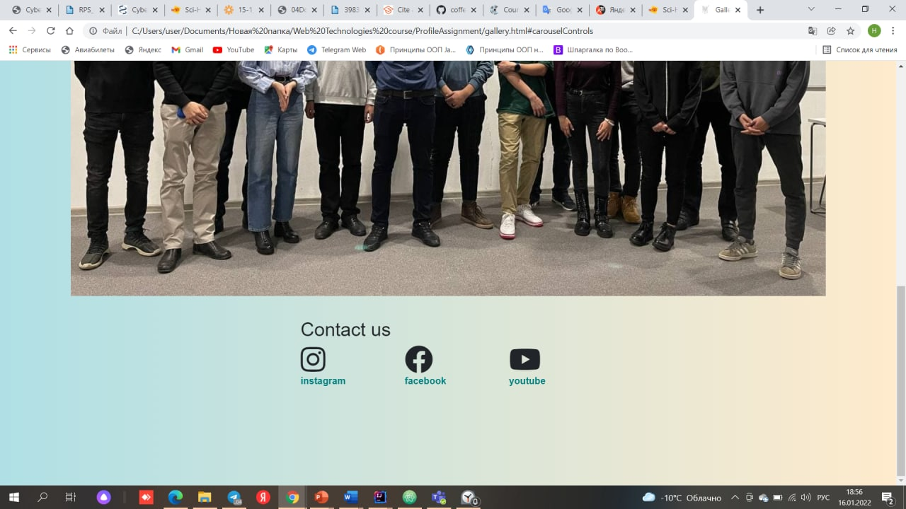

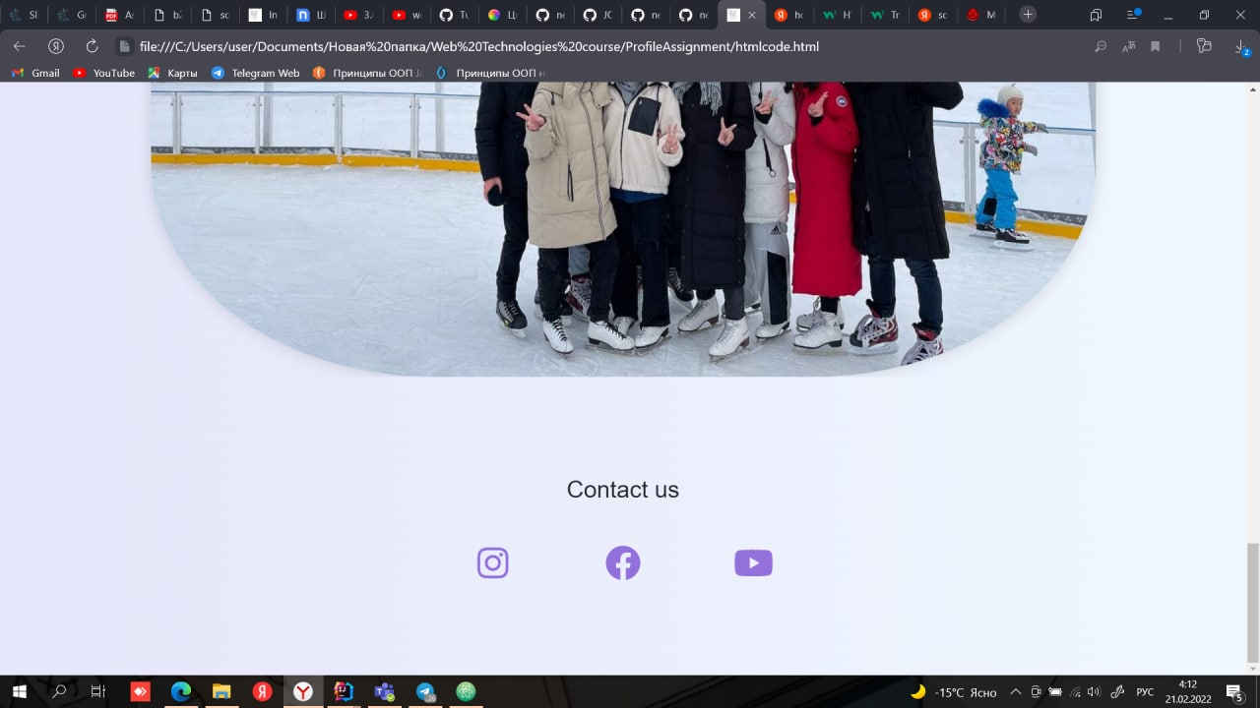

In this project, Nazerke was responsible for tables upgrade.

Aida for improving the questionnaire.

Marat made the navigation bar more convenient,

The rest of the small details were divided among themselves.

**PROGRESS [optional]**

|  |  |
| --- | --- |
| 10.01.2022 | Week 3 and 4 studies |
| 11.01.2022 | Learning Bootstrap |
| 12.01.2022 | Allocation of responsibilities |
| 13.01.2022 | Studying services for interface development |
| 14.01.2022 | Marking our coding’s for design |
| 16.01.2022 | Adding finishing details |

|  |  |
| --- | --- |
| 23.01.2022 | Learning UX/UI design |
| 30.01.2022 | Learning JavaScript |
| 6.02.2022 | Working with DOM |
| 13.02.2022 | Learning jQuery |
| 20.02.2022 | Final project upload |